TALENT FORGE

KNOWLEDGE TRANSFER (KT) DOCUMENT

Created By | Hooria Saeed
Reviewed By | Iqra Farooq
Document Status | Reviewed
Date | June 23, 2026

Table of Content
1. Platform Overview
1.1 Core User Roles
1.2 Dual-Role Identity: Agent ↔ Candidate Switching
2. Glossary of Terms
3. Environments & Access Credentials
3.1 Development Environment
3.2 Test Accounts
3.3 Design Reference
3.4 Video Overview of Talent Forge
4. Platform Architecture & Navigation
4.1 Role & Portal Flow
4.2 Full Sitemap (All Portals)
5. Candidate Portal
5.1 Document Upload (Candidate Responsibility)
6. Agent Portal
6.1 Candidates Tab — Status Filters
6.2 Verifications Workflow
6.3 Activity Log
7. Superadmin Portal
7.1 Analytics
7.2 User Management
7.3 Configuration & Audit Logs
8. Account Settings (Shared Across Roles)
9. Login Page
9.1 Layout
9.2 Login Flow
10. SignUp Page
10.1 Sign Up Flow
10.2 Agent Code Specifications
10.3 First-Time Agent Invitation
11. Switching Between Agent and Candidate Dashboards
11.1 Step 1 — Open the Account Dropdown
11.2 Step 2 — Confirmation Modal
11.3 Step 3 — Switched Into Candidate Portal
12. Appendix A
A.1 Links
A.2 Tabs
A.3 Confirmed Responsibility Split

1. Platform Overview
TalentForge is a web-based career readiness platform built for the Saudi market, designed to bridge the gap between university graduates and corporate employment. The platform serves Saudi fresh graduates and Co-Op and Tamheer program candidates through three portals: a Candidate Portal where users complete a psychometric assessment, enroll in personalised learning tracks, earn certificates, and engage with their university community; an Agent Portal where agents manage their assigned candidate portfolios, monitor progress, verify documents, and track performance against targets; and a Super Admin Portal that provides full platform governance including agent management, configurations, audit logging, and analytics. Subscription-gated access to learning tracks is processed via PayTabs, with Microsoft and Google SSO available across the platform. A Recruiter Portal is planned for Phase 2, enabling corporate hiring managers to search and shortlist vetted candidates directly, closing the end-to-end talent pipeline. TalentForge is aligned with Saudi Vision 2030 and compliant with HRDF Tamheer and Ministry of Education Co-Op program requirements.

1.1 Core User Roles
Role | Description | Primary Goal
Candidate | A Saudi fresh graduate or final-year university student (Co-Op or Tamheer participant) who registers on TalentForge to build their career readiness. They complete a psychometric assessment, enroll in a personalised learning track, and work toward certification and eventual corporate placement. | Allow candidates to learn, take courses and certifications.
Agent | Recruiter/consultant who manages a pool of candidates: reviews documents, verifies identity/qualifications, and tracks candidate pipeline status. | Move candidates efficiently from submission to verified/active status.
Superadmin | The platform owner and operator with full administrative control over TalentForge. The Super Admin manages agents, oversees the entire candidate base, configures platform settings, assigns promo codes, manages university communities, and maintains a complete audit log of all administrative activity. | Govern the platform, and manage user accounts of agents and candidates.

1.2 Dual-Role Identity: Agent ↔ Candidate Switching
A distinctive feature of Talent Forge is that a single logged-in user (e.g. an Agent) can switch into the Candidate experience without logging out, via a “Become a Candidate” option in the account dropdown, and switch back to the Agent Portal at any time. This is covered in detail in Section 10.

2. Glossary of Terms
Term | Meaning in Talent Forge
Agent Portal | The workspace used by recruiters/agents to manage candidates, verify documents, and track activity.
Candidate Portal | The candidate-facing interface where graduates register, complete their psychometric assessment, and manage their entire learning journey. It gives candidates access to their personalised learning track, courses, certificates, subscription management, referral program, and their university community.
Superadmin Portal | The top-level administrative workspace to take overview of their profile and deactivate/re-activate & send change email verification.
Verification | The process by which an Agent reviews a candidate's uploaded documents and confirms their authenticity/validity.
Requires Attention | A candidate status indicating something in their submission needs to be corrected or re-reviewed before verification can proceed.
Active / In Progress / Deactivated | Candidate pipeline statuses tracked in the Agent Portal's Candidates tab (see Section 4.2).
My Tracks | The candidate-facing section for tracking learning/ training progress.
Refer & Earn | A referral program tab in the Candidate Portal, allowing candidates to refer others, typically for a reward or incentive.
Activity Log | An Agent and candidate facing log of actions taken.
Audit Logs | A Superadmin-facing, platform-wide log of administrative and system actions, used for compliance and traceability.
SSO | Single Sign-On — Talent Forge's login page supports logging in via Google or Microsoft in addition to email/password.

3. Environments & Access Credentials
CONFIDENTIALITY NOTICE: This section contains live Dev login credentials. Treat this document as restricted/internal. Do not forward outside the immediate project team, and rotate these credentials if this document is ever shared broadly.

3.1 Development Environment
Dev URL: https://dev.talentforge.com.sa

3.2 Test Accounts
Role | Email | Password | Notes
Agent & Candidate | faran.mustafa@bytecorp.io | StrongPass123! | Single account; capable of switching between Agent and Candidate views.
Superadmin | superadmin@talentforge.com.sa | Byte1234 | Full administrative access.

3.3 Design Reference
Figma File: https://www.figma.com/design/ITGdpAWrNPSZ8clDTHKsfZ/Talent-Forge?node-id=217-1932&t=qkJPIHJntEnr1rrf-0

3.4 Video Overview of Talent Forge
Google Drive File: https://drive.google.com/file/d/19WcYofaStzl-yoA5phPQ3D6WAiJg0g6O/view?usp=sharing

4. Platform Architecture & Navigation

4.1 Role & Portal Flow
The diagram below summarizes how a user authenticates and is routed into one of three portals, and how the Agent ↔ Candidate switch works.
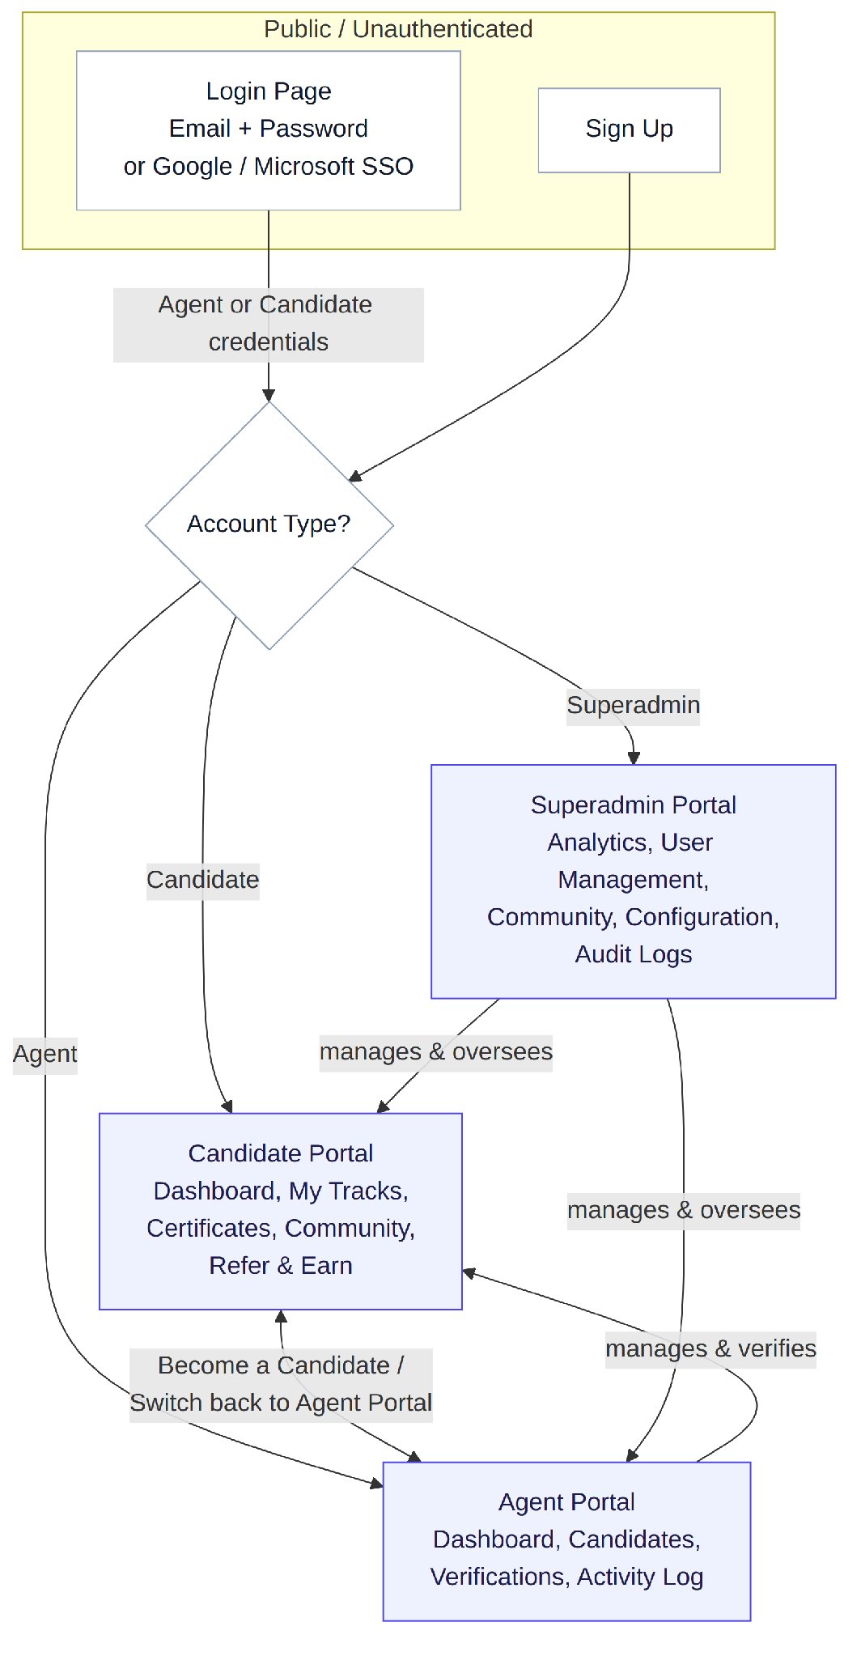
Figure 1: High-level role & portal flow

4.2 Full Sitemap (All Portals)
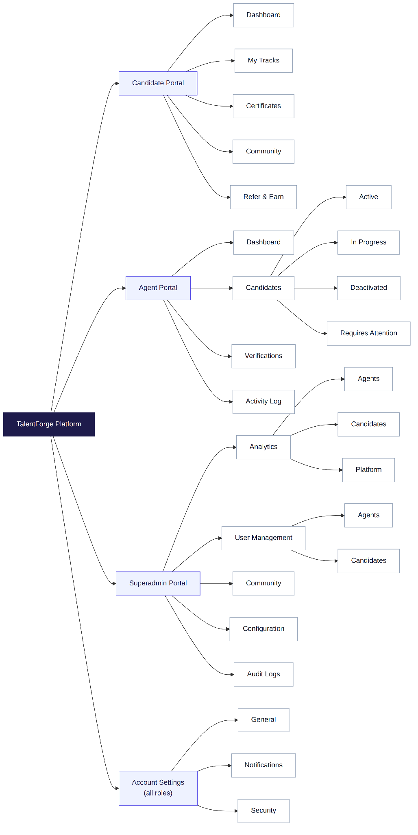
Figure 2: Complete navigation tree across Candidate Portal, Agent Portal, Superadmin Portal, and shared Account Settings

5. Candidate Portal
The Candidate Portal is where a job seeker manages their profile, progress, and engagement with the platform community.
Tab | Purpose
Dashboard | Landing screen after login for a Candidate. This summarizes courses completed, learning streak, candidate’s documents and earned certificates.
My Tracks | Displays the candidate's learning/training roadmap(s) and progress through them.
Certificates | Stores and displays certificates earned by the candidate, likely downloadable/shareable. Your certificates will appear after you complete courses and receive them.
Community | A community space for candidates to view other candidates from multiple universities.
Refer & Earn | Referral program where candidates can invite others and earn a reward/incentive.

5.1 Document Upload (Candidate Responsibility)
Candidates are required to upload supporting documents (e.g. identity verification, qualifications/certifications, or other compliance documents) as part of completing their profile. These uploads feed directly into the Agent's Verifications workflow described in Section 6.

6. Agent Portal
The Agent Portal is the recruiter-facing workspace for managing a portfolio of candidates and performing document verification.
Tab | Purpose
Dashboard | Landing screen for an Agent, summarizes total candidate counts by status, pending verifications, and document that requires attention.
Candidates | The core candidate-management list, segmented into four sub-views: Active, In Progress, Deactivated, and Requires Attention (see 6.1).
Verifications | Dedicated workspace for reviewing and actioning candidate document submissions and statuses.
Activity Log | Chronological record of actions the Agent has taken (status changes, verifications completed, notes added).

6.1 Candidates Tab — Status Filters
Status | Meaning
Active | It's when the personalized track is created, (candidate may not have subscribed). Personalized track is ready when:  A psychometric test is done, and the profile is completed.
In Progress | In-Progress means candidate have either:  1. Incomplete Onboarding  2. Psychometric test not taken  3. Profile Incomplete
Requires Attention | Something is blocking progress — e.g. an invalid/expired document, missing information, or a flagged discrepancy that the candidate or Agent needs to act on.
Deactivated | It shows the agent's candidates that have been deactivated by the superadmin.

6.2 Verifications Workflow
Per the confirmed responsibility split: candidates upload documents, and Agents verify them. The drafted step-by-step flow is:
- Candidate uploads a required document via the Candidate Portal.
- Document appears in the Agent Portal, associated with that candidate's record (in Document Verification Queue).
- The agent opens the document, reviews it against required criteria.
- The agent approves or rejects it.
- The candidate is notified of the outcome and, if rejected, can re-upload a corrected document.
- Every action is recorded in the Agent's Activity Log.

6.3 Activity Log
Capture an auditable trail of Agent actions, for example:
- Candidate status changed (e.g. In Progress → Active)
- Document approved / rejected, with timestamp and Agent identity
- Notes or comments added to a candidate record

7. Superadmin Portal
The Superadmin Portal sits above the Agent and Candidate experiences, with platform-wide visibility and configuration control.
Tab | Purpose
Analytics | Platform-wide reporting, split into three sub-views: Agents, Candidates, and Platform (see 7.1).
User Management | Administration of user accounts, split into two sub-views: Agents and Candidates (see 7.2).
Community | Superadmin-level oversight of the Communities also seen in the Candidate Portal.
Configuration | Platform-wide settings and configuration controls.
Audit Logs | Platform-wide, log of administrative and system actions, for traceability.

Analytics
- Agents — Display number of total active agents, average candidates managed per agent, Top Performing Agents, average verification time, total revenue generated, documentation overview and breakdown.
- Candidates — Display total candidates by status (Active/In Progress/Requires Attention), candidates by university, city, candidate journey funnel, progress & learning activity, trends and activity.
- Platform — Display overall platform signup, profiles completed, performance metrics.

7.2 User Management
- Agents — Allow Superadmin to view, invite, edit, deactivate, or reassign Agent accounts.
- Candidates — Allow Superadmin to view and directly update Candidate records.

7.3 Configuration & Audit Logs
Configuration include platform-wide settings for example: edit list of universities, fields of study, desired roles or referral program parameters including refer & earn limit
and promo code discount. Audit Logs provide a tamper-evident, chronological record of administrative actions across the whole platform.

8. Account Settings (Shared Across Roles)
Account Settings is accessible from the account dropdown menu (top-right, shown in Figure 3 below) and is available to all roles, organized into three tabs.
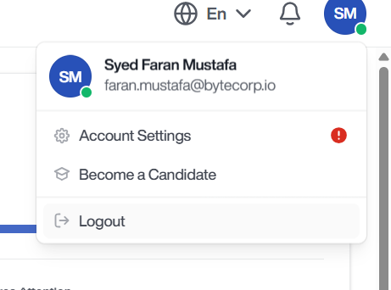
Figure 3: Account dropdown menu (top-right user avatar), showing name, email, Account Settings, Become a Candidate, and Logout
Tab | Contents
General | Basic Information: First Name, Last Name, Email, Phone Number
Notifications | Email notification control
Security | Cover password change, and two-factor authentication management.

9. Login Page
The login page accepts an Email Address and Password, including a “Forgot password?” link, and offers SSO login via Google or Microsoft. New users can navigate to Sign Up from the same screen.

9.1 Layout
- Email Address field
- Password field
- “Forgot password?” link
- “Log in” primary action button
- Google and Microsoft SSO buttons
- “Don't have an account? Sign up” link for new users

9.2 Login Flow
- User lands on the Login page at the dev URL.
- User enters email + password, or selects Google/Microsoft SSO.
- The system authenticates the credentials and determines account type (Agent, Candidate, or Superadmin).
- The user is routed to the corresponding portal's Dashboard.

10. SignUp Page
The sign-up page allows new users to register an account by providing their personal details, an agent code, and setting up a secure password. It also supports quick registration via Google or Microsoft SSO. Existing users can easily navigate back to the login screen.

10.1 Sign Up Flow
- User Navigation: User lands on the Sign Up page (either via direct URL or by clicking the "Sign up" link from the Login screen).
- Data Input: User fills out all required fields (First Name, Last Name, Email, Agent Code, Password, and Password Confirmation) OR selects Google/Microsoft SSO for registration.
- Validation & Account Creation:
  - The system validates that all fields are correctly formatted, passwords match, and the provided Agent Code is valid.
  - Upon successful validation, the system creates the new user account.
- Redirection: The user is successfully registered and automatically routed to the onboarding flow or the designated portal's Dashboard.

10.2 Agent Code Specifications
- Field Definition: A mandatory alphanumeric inputFirst-Time Agent Invitation field used exclusively during manual sign-up to verify and link a user to a specific agency, organization, or internal team.
- Role Association: The presence of this valid code during registration automatically flags the user's account type as an Agent within the system architecture.
- Validation Rules:
  - Required Field: Registration cannot proceed if this field is left empty.
  - System Lookup: Upon clicking "Create Account", the system must validate the entered code against an existing database of authorized active agent codes.

10.3 First-Time Agent Invitation
Upon successful registration with a valid Agent Code, users identified as Agents will be presented with a one-time invitation modal immediately after account creation. This modal allows agents to invite candidates to the platform before proceeding to onboarding or the dashboard. The modal is displayed only during the agent's initial registration and will not appear on subsequent logins or sessions.

11. Switching Between Agent and Candidate Dashboards
Talent Forge allows a single logged-in user to operate as both an Agent and a Candidate, switching between the two experiences without logging out.

11.1 Step 1 — Open the Account Dropdown
From any screen in the Agent Portal, the user opens the account dropdown (top-right avatar) and selects “Become a Candidate.”
Figure 3 (repeated for reference): Account dropdown — “Become a Candidate” sits between Account Settings and Logout

11.2 Step 2 — Confirmation Modal
Selecting “Become a Candidate” opens a confirmation modal explaining the switch, with the option to stay in the Agent Portal or proceed.
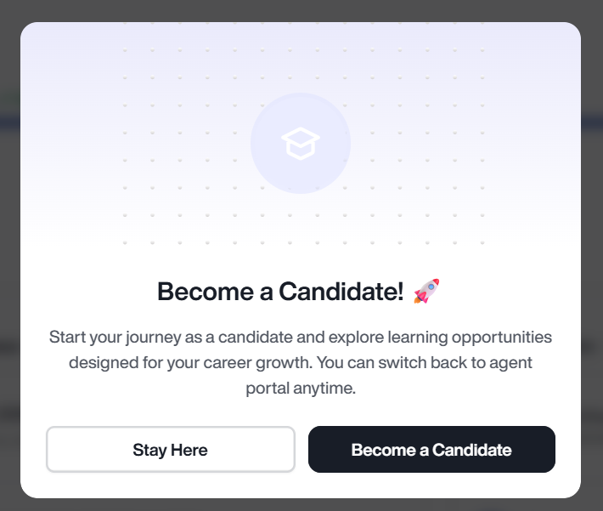
Figure 4: “Become a Candidate” confirmation modal

11.3 Step 3 — Switched Into Candidate Portal
On confirming, the user is taken into the Candidate Portal (Dashboard, My Tracks, Certificates, Community, Refer & Earn — see Section 5). The same account dropdown is shown to now offer a way to switch back to the Agent Portal, consistent with the modal's stated promise that the user “can switch back to agent portal anytime.”

12. Appendix A
For traceability, this appendix preserves the links.

A.1 Links
Google Drive Video Overview: https://drive.google.com/file/d/19WcYofaStzl-yoA5phPQ3D6WAiJg0g6O/view?usp=sharing
Dev Environment: https://dev.talentforge.com.sa
Figma (access-restricted): https://www.figma.com/design/ITGdpAWrNPSZ8clDTHKsfZ/Talent-Forge?node-id=217-1932&t=qkJPIHJntEnr1rrf-0

A.2 Tabs
Candidate Portal: Dashboard, My Tracks, Certificates, Community, Refer & Earn.
Agent Portal: Dashboard, Candidates (Active / In Progress / Deactivated / Requires Attention), Verifications, Activity Log.
Superadmin: Analytics (Agents, Candidates, Platform), User Management (Agents, Candidates), Community, Configuration, Audit Logs.
Account Settings (all roles): General, Notifications, Security — with General containing First Name, Last Name, Email.
Login: Email Address, Password, Forgot password?, Log in button, “Or login with” → Google / Microsoft, “Don't have an account? Sign up.”

A.3 Confirmed Responsibility Split
- Candidates are required to upload documents.
- Agents perform verification of those documents.
- Superadmin can update both Agent and Candidate records.

End of Document

